Curriculum Vitae (C.V.)
- Personal data:
Name (Arabic) | شروق صبري عبدالله محمد
Name (English) | Shrook Sabry Abdallah Mohamed
Department | Pathology
College | Faculty of medicine
Academic degree | Assistant Lecturer
Office Address | Toukh
Mobile 1 | 01554791110
Home phone | 0133390745
Work phone
Fax
Email (university) | s.hassan48158@fmed.bu.edu.eg
Email (alternative) | shrookasabry@gmail.com
Web site (if any)
Recent Photo (passport format) | 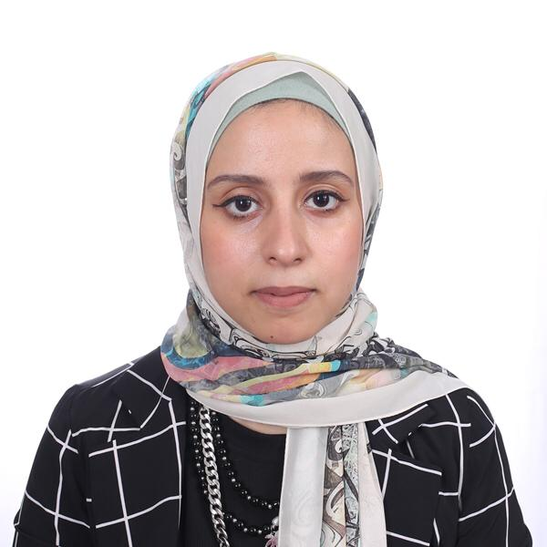
- Education:
2.A. Degree obtained;
Institution | Degree obtained | Year
Faculty of Medicine  Banha University | Msc of Pathology | 2025
Faculty of Medicine  Banha University | MB,BCh | 2019

2.B. Specialty;
General specialty. | Pathology
Specific specialty.

2.C. Language skills (Excellent, Very Good, Good or Basic);
Language | Reading | Speaking | Writing
Arabic. | Excellent | Excellent | Excellent
English. | Excellent | Very good | Excellent
French. | - | - | -
Other (specify). | - | - | -

- Positions:
Position | Year | University/Institution
Demonstrator | 2021-2025 | Benha faculty of Medicine
Assistant Lecturer | 2025-present | Benha faculty of Medicine

- Cooperation with local and international entities having website:
( جامعة – مؤسسة - وزارة – مركز بحثي – عضو هيئة تدريس – باحث - شركة – مصنع – الخ)
Name of local and international entity | Website
- Membership of professional bodies (List):

- Membership of institute (List):

- Distinction and Awards (List):

- Academic:
Courses at under graduate level;
 | Clinical rounds;
2. Course name: | Lectures;

Teaching pathology courses of under graduate
Courses at post graduate level;
1. Course name:1. Course name:أخلاقيات البحث العلمى  TOEFl  Computer  الكتابة العلميه  الاحصاء | Clinical rounds;
2. Course name: | Lectures;

- Areas of research: Benha medical journal

- PhD/M.Sc Supervision:
Title | PhD/M.Sc | Year completed / in progress

- Grants for Projects:
Funding organization | Project title | Role | Year
- Committees:

- List of Publications:
14. Attended Workshops, Symposiums, and Conferences: "List name and year";

Name of Workshops, Symposiums, and Conferences | Year
13.1. workshop of pathology at pathology department , Banha Faculty of medicine  Attendance conference of Benha Faculty of medicine. | 2021  2023

- Books published:

16. Positions:
 | Date | Organization | Country | Position
1
2
3

17. Activities in faculty/university/community service:
Name of Activity service | Year
Teaching (Rounds and lectures).Teaching Sections | 2021- present
- Clinical meeting.
- Making conferences. | 2023
- Medical Convoys.
- Workshops.
18. Consulting Experience (if any):

19. Additional information you would like to put on the website:

